**OOP Final Project Report**

**New Gulshanabad Society**

**GROUP MEMBERS**

Muaaz Bin Aleem SP21-BCS-049

Mohid Anwar SP21-BCS-047

**SUBMITTED TO:**

Maam Saneeha Aamir

Object Oriented Programming - CSC24

Table of Contents

Description 3

Functionalities 3

Login/Signup 3

Admin and Member Section 3

Villa and Flats 3

File Operations 3

Screenshots 4

# Description

Our code is titled “New Gulshanabad Society” which allows the user to buy and register property. The user can buy either Plots or villas which have their own Tax schemes.

The system is mainly divided into two parts: Admin and Owner. All accounts are password protected.

# Functionalities

## Login/Signup

After Acquiring appropriate details the user can login or the user can provide details to sign up as well. The login is done on the basis of email id

## Admin and Member Section

The Admin section has its own two menus: Admin Property Menu and Admin Owner Menu. The admin can:

* Register Properties
* Search and Update Properties
* Removal of an Owner
* Display and Update Owner data

The Members of the society can search for their own property and determine its details accordingly

## Villa and Flats

Each Flat and Villa have their own:

* Price
* Size
* Address
* Owner

An interface “Taxable” is used and for each type of property a different tax value is assigned.

## File Operations

All of the owner and admin accounts were stored in files. The Flats and Villas were also stored in files. All basic file operations such as deletion, addition, updation and display (specific and all) are accounted for

# Screenshots

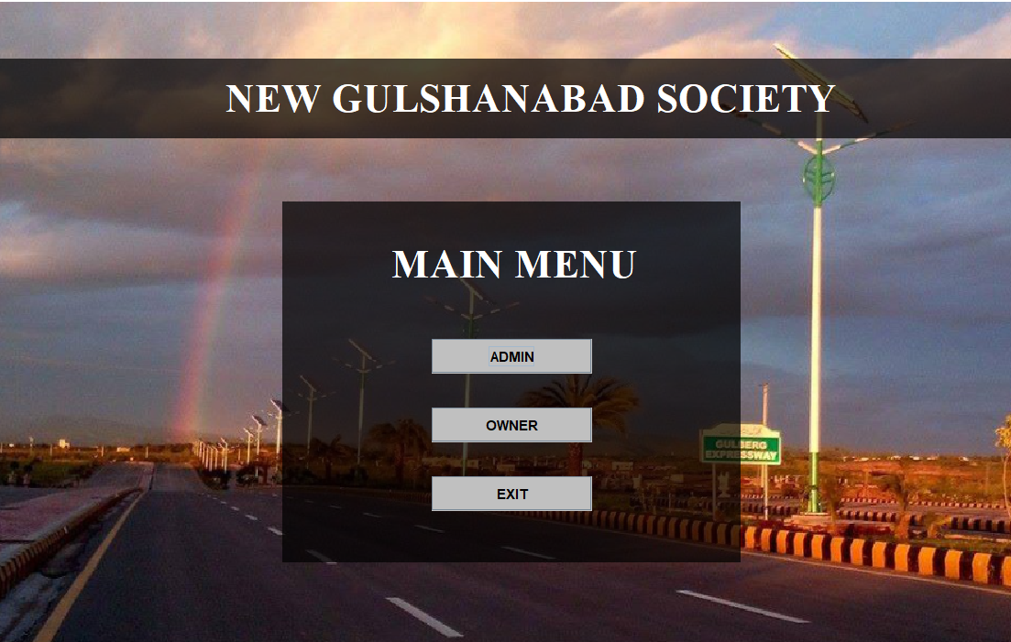

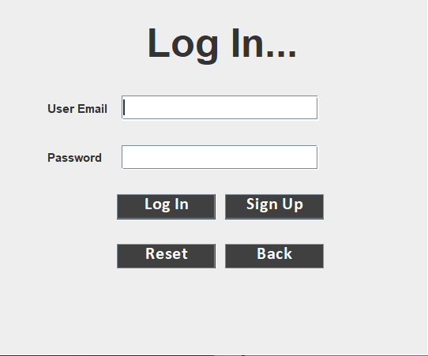Figure 1: Main Menu Frame

Figure 2 : Login / Signup Frame

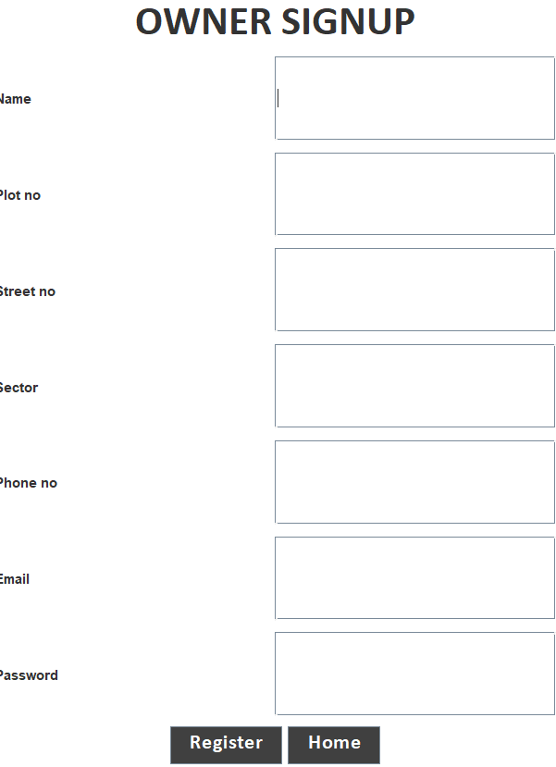

Figure 3: Signup Frame

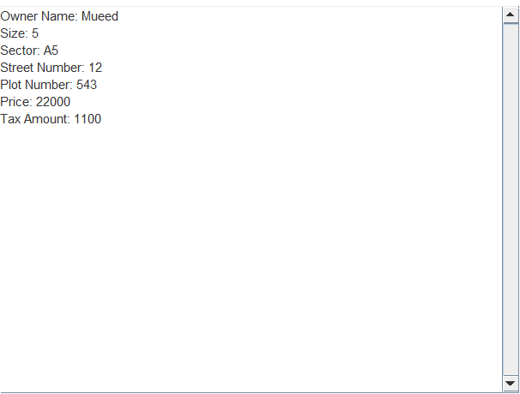

Figure 4: Villa Display Frame

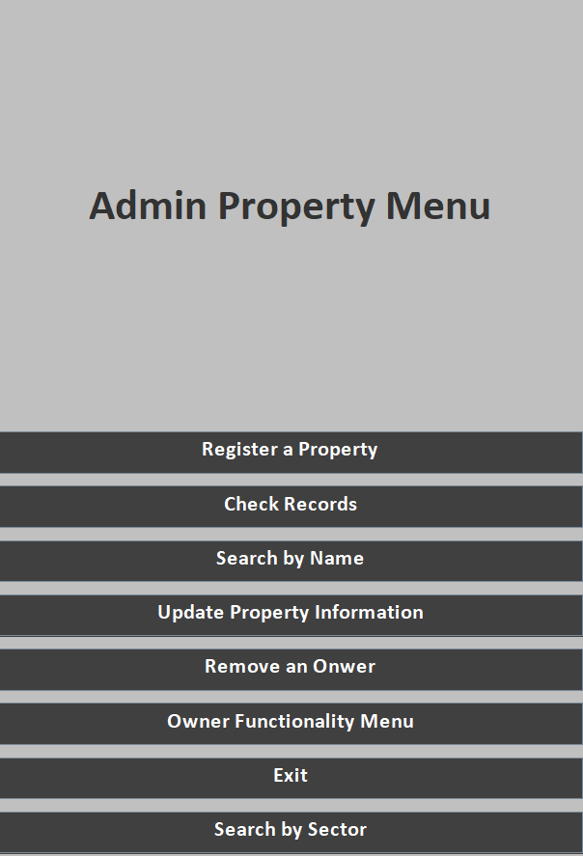

Figure 5: Admin Property Menu

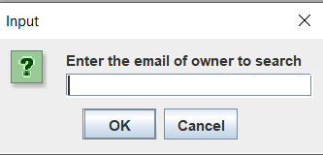

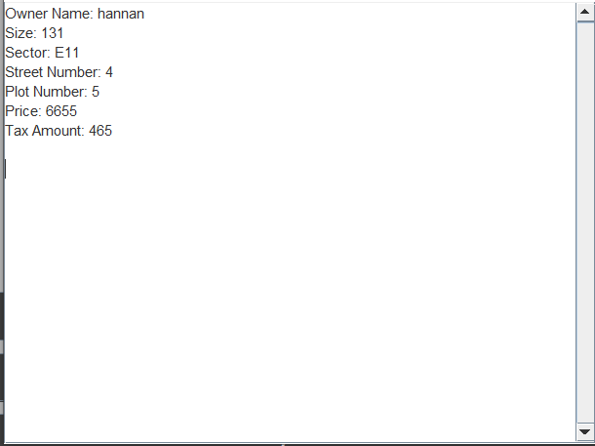

Figure 6: Specific Flat Finder

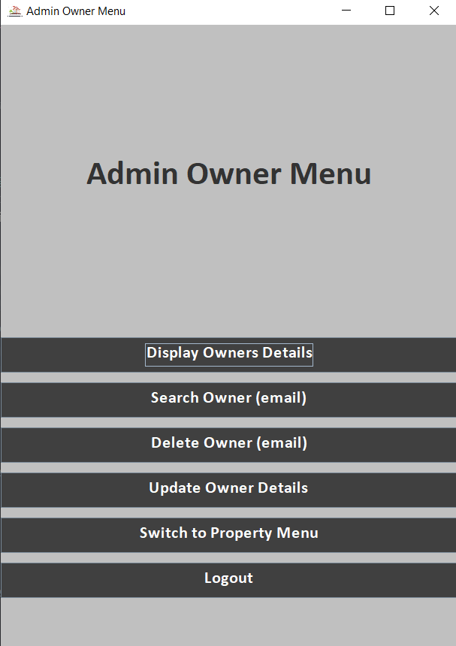

Figure 7: Admin Owner Menu